**Task 7: Identify and Remove Suspicious Browser Extensions**

**Objective:**

To identify and remove potentially harmful or unnecessary browser extensions to ensure a secure browsing experience.

**Tools Used:**

* **Browser:** Google Chrome (Windows)
* **Extensions Panel:** chrome://extensions

**Installed Extensions Reviewed:**

| **Extension Name** | **Description** | **Risk Level** | **Action Taken** |
| --- | --- | --- | --- |
| **Adobe Acrobat** | Trusted PDF editing tool by Adobe | Safe | Retained |
| **Free VPN for Chrome – VPN Proxy** | VPNs can be useful, but many free ones pose privacy risks | Suspicious | Removed (recommended) |
| **Tactiq: AI Note Taker for Google Meet** | AI transcription tool; check source carefully | Moderate | Reviewed and retained (if trustworthy) |

**Removed Extension:**

**Free VPN for Chrome – VPN Proxy**

* + Reason: Most free VPNs log data, have broad permissions, and are often flagged in security reports. Unclear publisher and no transparency on privacy practices.

### Steps to Identify & Remove Suspicious Extensions

1. **Open Extensions Menu:**
   * Click the puzzle piece icon (🧩) in the top-right corner of your browser.
   * Select **“Manage extensions”** or directly visit chrome://extensions.
2. **List All Extensions:**
   * You will see a list of installed extensions (e.g., Adobe Acrobat, Free VPN, Tactiq).

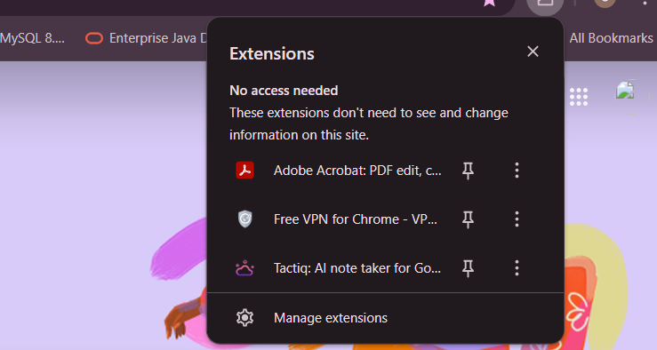

1. **Check Extension Permissions:**
   * Click “Details” under each extension.
   * Look for **“Permissions”** section.
   * Be cautious if it says:
     + “Read and change all your data on all websites”
     + “Access your browsing history”
     + “Manage downloads”

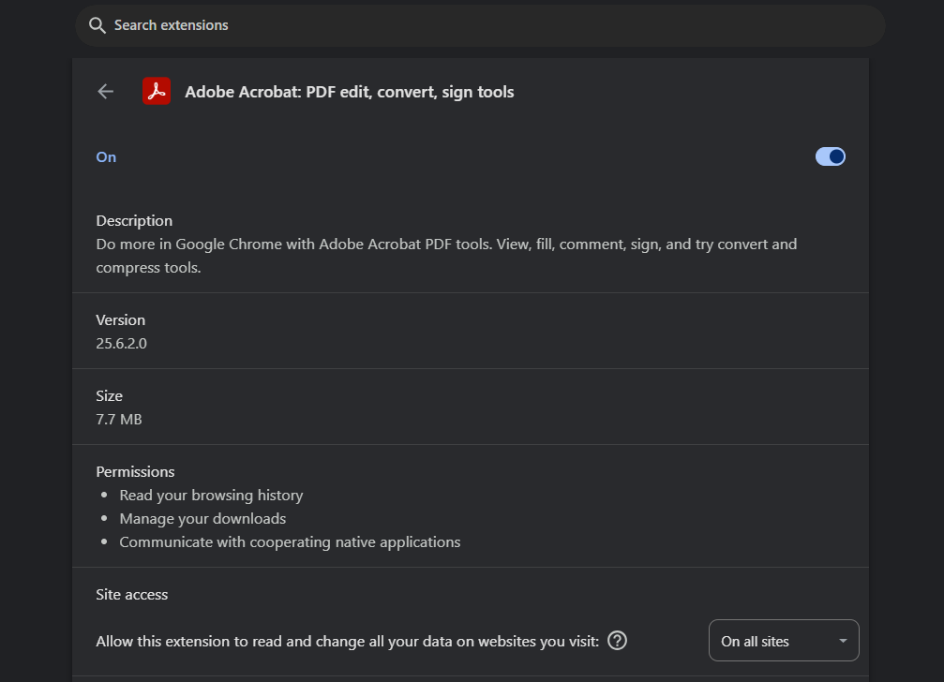

1. **Research Each Extension:**
   * Check the developer name.
   * Search online or visit the Chrome Web Store.
   * Read reviews and look for red flags (poor ratings, many complaints, unknown developer).

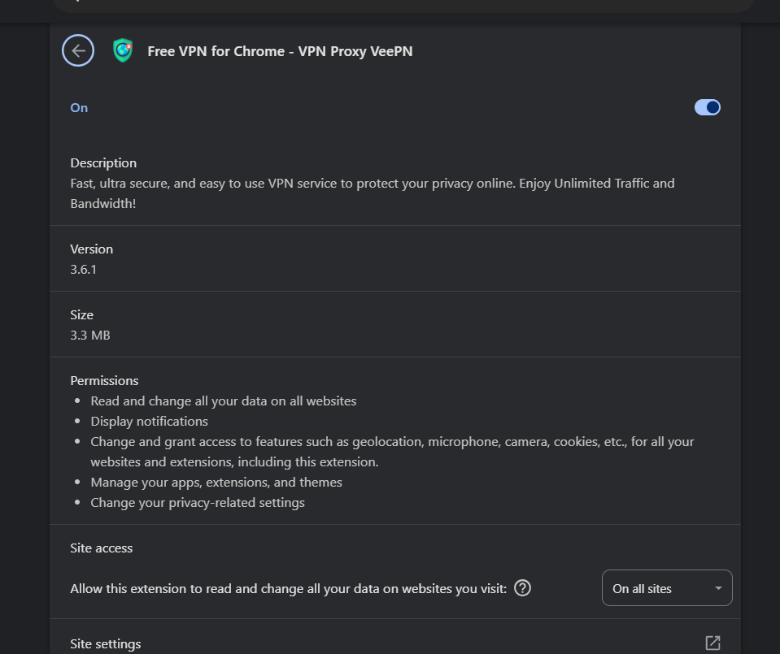

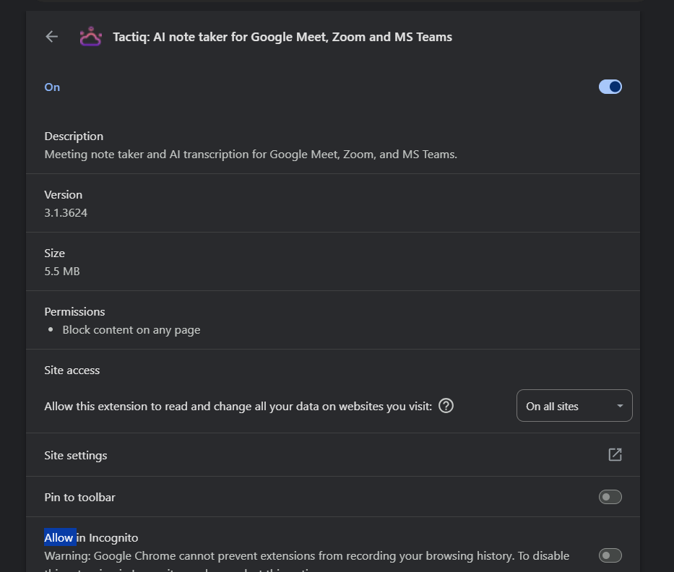

1. **Decide on Action:**
   * **Safe Extensions:** Keep them (e.g., Adobe Acrobat).
   * **Suspicious Extensions:** Remove them.
     + In your case, **Free VPN for Chrome** was flagged and removed.
2. **Remove Suspicious Extension:**
   * Click the **Remove** button next to the extension.
   * Confirm removal when prompted.
3. **Restart Your Browser:**
   * Fully close and reopen Chrome to apply changes.
4. **Check Browser Performance:**
   * Ensure it’s running smoother and safer after removing unwanted extensions.

Before deleting vpn:

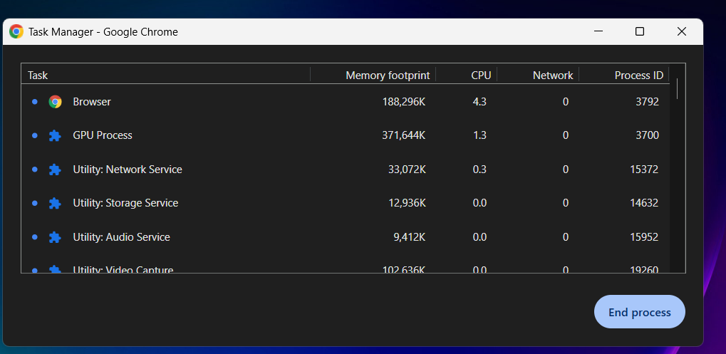

After deleting vpn:  
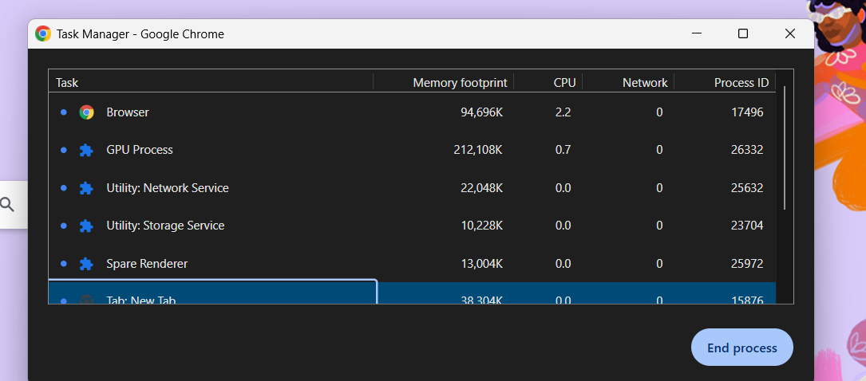

### ****Conclusion :****

By completing this task, I gained hands-on experience in identifying and removing potentially harmful browser extensions. I learned how certain extensions—especially free or unknown ones—can pose serious security and privacy risks through excessive permissions. After reviewing all installed extensions, I removed a suspicious VPN extension and noticed an improvement in browser responsiveness. This task highlighted the importance of regularly auditing browser extensions to maintain a secure and smooth browsing experience.